**Evolution in Tracking through RFID**

**(Radio Frequency Identification)**

A REPORT SUBMITTED IN PARTIAL FULFULMENT OF THE REQUIREMENTS FOR THE DEGREE OF

BACHELOR’S IN COMPUTER SCIENCE

**Submitted By**

Ali Raza 2017-uam-656 2017-2021 Muhammad Ahmad Gull 2017-uam-638 2017-2021

Muhammad Mubeen 2017-uam-660 2017-2021

**Supervised By**

Sir Israr Hussain



**Muhammad Nawaz Shareef University of Agriculture Multan**

Department of Computer Science

**DECLARATION**

This is to certify that Student Names (Reg Nos.), Session (2017-2021) have worked on and completed their software project “Evolution in Tracking Through RFID” at the Department of Computer Science/IT, MNS-University of Agriculture, Multan, in partial fulfillment of the requirements for the degree of BS (Computer Science).

# *Date:_____________*

# Signature: _____________________

# Ali Raza Reg. No. 2017-uam-656

# Signature: _____________________

# Muhammad Ahmad Gull

# Reg. No. 2017-uam-638

# Signature: _____________________

# Muhammad Mubeen Reg. No. 2017-uam-660

**DEDICATION**

***To our Loving Parents***

**Acknowledgement**

We humbly thanks to **Almighty Allah**, the one who only knows concealed and open. Our thankfulness is also for all our **Family Members** for their excessive moral and financial support. Their prayers were incessant and enabled me to reach this stage. We are also thankful to my all family and to my **grandparents** for their kindness, love and ever supporting prayers.

It is our pleasure to express our heartfelt thanks to **Mr. Israr Hussain**, Lecturer, Department of Computer Science, who in-spite of being extraordinary busy with her duties, took time to give invaluable advice and guidance throughout the development of the Project.

Last but not the least, I am grateful for the unselfish cooperation and assistance that my friends had given me to complete this task. In addition, I would like to thank everyone who had contributed to the successful completion of this project.

**PROJECT BRIEF**

|  |  |
| --- | --- |
| PROJECT NAME | Evolution In Tracking Through RFID |
| ORGANIZATION NAME | MNS – University of Agriculture, Multan |
| UNDERTAKEN BY | Ali Raza  Muhammad Ahmad Gull  Muhammad Mubeen |
| SUPERVISED BY | Sir Israr Hussain |
| STARTING DATE | Nov 26.2019 |
| COMPLETION DATE | <<__________>> |
| COMPUTER USED | Intel(R) Core(TM) i7-3740QM CPU @ 2.70GHz 2.70 GHz |
| OPERATING SYSTEM | Windows 10 Pro |
| SOURCE LANGUAGE(S) | C#, Java |
| DBMS USED | SQL |
| TOOLS/PACKAGES | Visual Studio 2019, MSSQL Server Express Edition 2017, Android Studio |

**PLAGIARISM UNDERTAKING**

I solemnly declare that the work presented in the report titled “***Evolution in Tracking through RFID.***” is solely our work with no significant contribution from any other person. Small contribution/help wherever taken has been duly acknowledged and that complete report has been written by us.

I understand the zero-tolerance policy of the HEC and MNS-University of Agriculture, Multan towards plagiarism. Therefore, I as an Author of the above titled report declare that no portion of my report has been plagiarized and any material used as reference is properly referred/cited.

I undertake that if I am found guilty of any formal plagiarism in the above titled report even after award of the degree, the University reserves the rights to withdraw/revoke my degree and that HEC and the University has the right to publish my name on the HEC/University Website on which names of students are placed who submitted plagiarized report.

_________________

Ali Raza

2017-uam-656

_________________

Ahmad Gull

2017-uam-638

_________________

Muhammad Mubeen

2017-uam-660

**Abstract**

In the field of supply chains and warehouses there are some threats like Accidental redundancy Shrinkage Loss, Misplacement Loss, Cycle Count Time, and Out-of-stock inventory. Accepting an order on the assumption that you have enough stock to fulfill it, and only later finding out that you don’t. Now you have to place a backorder, which significantly extends your order lead time. Denying an order after assuming that you don’t have enough stock to fulfill it, but then finding out that you do.

A study by AMR Research found that business with excellent order rates of 80% or higher are three times more profitable than those with order rates of 60%. There’s a common notion that only automation and equipment is expensive. But what several warehouse managers fail to realize is that manual labour doesn’t come cheap either. According to Kane Logistics, labor is one of this biggest expenses some warehouses spend on, ranging from 50-70% of the overall warehousing budget. “Oracle and KPMG Cloud Threat Report.” Most preferable alternatives or user's credentials in MFA (Multi-factor authentication), finger print is in second place while a secure ID is in first place of 21%.

We will attach the RFID tags to each item required to be monitor through production process like while labeling items tags will be attached along with them. When it comes to retail, RFID tags can be scanned all at once. Because we have developed a system where mobile applications also have a role to play. Scanned stock can be seen and check through your mobile anywhere and anytime. Using RFID, weekly counts now will take an hour instead of half a day and this technology is easy to implement alongside current systems. Stock accuracy can be up to an impressive percentage and most importantly improved availability will led to positive customer feedback and happier staff.

Table of Contents

Chapter 1 10

Introduction 10

**Problem Statement** 11

**Motivation** 12

**Aim and objectives:** 12

**Scope of Project** 12,13

Chapter 2 14

Background Study 14

**Existing System** 15

**Flaws/drawbacks in existing system** 15

**Literature Review** 16

Chapter 3 17

SYSTEM ANALYSIS AND DESIGN 17

**System Analysis:** 18

**Functional Requirements:** 18

**Non-Functional Requirements:** 19

**Tools`** 20

**Software Requirements** 20

**Hardware Requirements** 20

**System Diagrams** 21

**Class Diagram** 21

**Use Case Diagram** 22

**ER-Diagram** 23

**State Chart Diagram** 24

**Activity Diagram:** 25

**Database Design:** 25

Chapter 4 26

Result and Analysis 30

**Implementation:** 30

**Important Mobile Source Code:** 32

**Fetching Data from Database:** 33

**Setting of Data in Defined TextView:** 33

**Desktop Application UI:** 34

**Mobile Application UI:** 44

Chapter 5 49

CONCLUSION & FUTURE WORK 48

**Conclusion:** 50

**Future Work** 51

Chapter 6 52

References 52

**References** 53

# Chapter 1

# Introduction

## **Problem Statement**

Physical counting of items and their management both processes are the top priority of every warehouse and supply chain department. But still now in Pakistan majority is maintaining them by their labors. They count items and it takes almost a half day and if we talk about huge number of stock it almost takes 2 to 3 days a week. There are also some problems they face like expecting to find a product in a certain room or hallway, but realizing that it’s actually placed somewhere else. Accepting an order on the assumption that you have enough stock to fulfill it, and only later finding out that you don’t. Now you have to place a backorder, which significantly extends your order lead time. Denying an order after assuming that you don’t have enough stock to fulfill it, but then finding out that you do.

So in order to overcome such problems we have used technology RFID in which every items needs to be monitored and tracked is tagged by a unique RFID tag. Some major problems are given below:

1. Wrong calculation in counting of available items.
2. If it is not wrong then it is time taking to calculate if items are in numbers of thousands.
3. It is very difficult to categorize the items according to their properties while in the process of stock management in manual systems.
4. It is also very time taking to physically search items with some specifications.
5. Also it takes time and manpower to get an order of some items and then then check it’s availability in stock.
6. Accidental redundancy
7. Shrinkage Loss
8. Misplacement Loss
9. Cycle Count Time
10. Out-of-stock inventory
11. It is nearly impossible to read all items in several warehouses simultaneously.
12. Identification of tagged items by category, value, priority, expiry date, etc.

**Motivation**

Our main motivation was the lack of efficiency of current running digital warehouse systems to track the shrinkage loss, accidental redundancy and out of stock inventory. Because to tackle with these problems only the solution is to go physically in the warehouse and do it compute them manually. As RFID systems are used to track sheep.

This era is focusing on RFID applications like Cattle monitoring and in Dry cleaning shops. But if talk about in high level this technology is being used in human recognition. Because of unique gate pattern of every human this is used to recognize them according to their gate pattern. It is not limited for this but now for location of any item can also be detected through this technology.

## **Aim and objectives:**

The main objective of this project is to develop applications incorporating RFID with other technologies/systems, on both software and hardware aspects. Software applications include a multi agent system used in the warehouse for controlling inventory and communicating with suppliers, rule based autonomous storage planning, and an RFID-based fuzzy storage assignment system and a case based reasoning. The hardware aspect of RFID applications includes a unique method of material tracking (using RFID and IR) in the warehouse proposed by NEC. Other examples include) combining RFID with a novel design of conveyor belt system for storage and picking of items to fulfil customer orders and enables enhanced storage utilization, proposing a warehouse robot that uses RFID to identify objects and places in the warehouse by reading their tags and is able to navigate to designated locations. Furthermore, there are other creative proof of concept models, such as unmanned air vehicle (UAV) flying in the warehouse aisles for stock taking, RFID-enabled hand glove for locating lost items and counting inventory and tracking frequent walks of warehouse operatives or retail customers to reveal frequently visited spots in the facility.

The efficiency and effectiveness of the supply chain network is depending on the performance of its functional elements, in particular, warehousing operations. They facilitate storage and buffer functions between upstream and downstream points of the supply chain. The core warehouse operations revolve around the flow of materials in the facility, which are receiving, put away, storage, order picking and dispatching. Receiving is the start of the warehousing process, in which the arriving items are unloaded from the transport carriers. Their identity, quantity and condition is checked at this stage, and items may be repacked to different stock keeping units, i.e. put into palletized or de-palletized, after which they await for the next process called put away. Put away is the process of physical moving of the received goods from the staging area to the locations in the warehouse, where they can be stored. Storage is the placement of goods in the facility for the purpose of safe keeping, protection and retrieval as required by the next activity. Order fulfilment or order picking refers to the removal of items from the storage locations for the purpose of fulfilling customer orders. Completed orders are checked to ensure picking accuracy and may be sorted or consolidated before dispatching. Consolidation refers to grouping multiple orders for the same destination. Dispatching is the last warehousing activity, in which goods are loaded onto the transport carrier. In addition to the aforementioned activities, warehouses also offer cross-docking function that coordinates products movement between receiving and dispatching activities. Inbound cargo is sorted, combined with other inbound deliveries and dispatched without being put to storage. Cross-docking operations serve the purpose of holding fewer inventory, reducing storage costs and improving service times.

## **Scope of Project**

The scope of the project is the system on which the software is installed, i.e. the project is developed as a multi-platform application, and for now it will only work for our targeted warehouse. But later on, project can be modified to operate on any type of warehouse.

# 

# Chapter 2

# Background Study

**Existing System**

The current method that the warehouses use is the build-in desktop application on their system or manually (bookkeeping method) which is just limited to there on stock, which sometimes stop working due to so much of searches in the stock and it gives a slip and after later it is checked by their shop member this is all just for the validation on their end. And it just not has the record of the customers also have of their suppliers from whom they getting this items & further there is inaccuracy regarding stock in our existing system means actually there remain stock of 50 medicines but the system is showing us the 70-medicine stock. Due to limitations like only personal stock checking why not make it big means build a desktop application that works through android application and customers have the reach to the warehouse through their home obviously online and have access to more than one warehouse to search for & the lack of accuracy is resolved by adding the RFID detection device.

**Flaws/drawbacks in existing system**

Manual systems put pressure on people to be correct in all details of their work at all times, the problem being that people aren’t perfect, however, each of us wishes we were.

* These items warehouses are manual.
* There is always a chance of inaccuracy (means actually stock remain of 50 items but the bookkeeping or desktop application system is showing of 80 items). Since these are manually so there is a great risk of error.
* More manpower is required
* Calculations related to items are done manually (total items and sold items)
* It is difficult to maintain a database or register in manual systems.
* It is difficult to search for particular data from this system (especially if the data, we are asking for, is of very long ago).
* The ability to compute the warehouses stock actual figure becomes a major task as manual computation production errors, and also wastes a lot of time.
* This method could easily allow for impersonation and the warehouse stock sheet could be stolen or lost.

## **Literature Review**

Application of Radio Frequency Identification (RFID) in managing supply chains has witnessed significant interest in recent years. However, the current understanding of the potential benefits that act as the motivating factors/drivers in implementing RFID technology (benefit-drivers), its link to competitive advantage, is fragmented and scattered across the literature. This formed the motivation of this study which seeks to address this gap in the literature through a systematic literature review. Based on a rigorous screening of the literature (2006–2018), the study develops a comprehensive understanding of the various 1) corporate-driven and 2) customer-driven benefit-drivers from RFID implementation. The “2 C” categorization of benefit-drivers is novel and should provide more impetus for practitioners to leverage from RFID implementation. Further, the link between the benefit-drivers and competitive advantage is understood and proposed in the form of a conceptual framework. Finally, avenues for future research are highlighted. The study findings and the framework provide a good starting point for academics and practitioners to further explore the opportunities in supply chain afforded by RFID implementation. A comprehensive review of this kind has not been previously undertaken and constitutes the novelty of this work.

RFID technologies may improve the potential benefits of supply chain management through reduction of inventory losses, increase of the efficiency and speed of processes and improvement of information accuracy. Various RFID systems can be obtained by combining different tags, readers, frequencies and levels of tagging, etc. The cost and potential profit of each system change in a wide range. In this paper, a state-of-the-art on RFID technology deployments in supply chains is given to analyze the impact on the supply chain performance. Potential benefits, particularly against inventory inaccuracy problems, the bullwhip effect and replenishment policies, are briefly surveyed. Various works addressing analytic modeling, simulations, case studies and experiments as well as ROI analyses are reviewed. Finally, conclusions and future research perspectives are presented.

# Chapter 3

# SYSTEM ANALYSIS AND DESIGN

## **System Analysis:**

Analysis can be defined as breaking up of any whole so as to find out their nature, function etc. System analysis and design can be characterized as a set of techniques and processes. This system manages to the analysis of the report creation of cards and develops manual entry of the detective card through RFID reader. First detect the card of warehouse item box and then store that card info into the database and when needed that particular card info the system will provide to us. This project will help the detection system for the warehouses calculate percentage and reports of the detective cards. The application detection system will provide flexible report for all items boxes through detection of cards.

### **Functional Requirements:**

Functional specifications are the requirements in which requires to operate a system. These requirements are necessary to assemble a system which will be required to attain the objectives. Some of the important functional requirements are outlined below by analyzing.

1. A user must be able to manage warehouses records.
2. An only authorized user must be able to use the system.
3. The administrator or the person who will be given the access to the system must login into the system before using it.
4. The information must be entered and managed properly.
5. First detect the cards on the item boxes by using the RFID reader.
6. Storing all the detected cards in a folder.
7. After recognizing cards the system add these cards info into database.
8. At last, the system will generate a report and Calculating the overall items percentage of warehouse.

### **Non-Functional Requirements:**

Non-functional Specifications are the needs based on the specific criteria to evaluate the operation of the system. These requirements are collected and analyzed based on the client needs and exceptions, security and working etc.

1. Accuracy and Precision: the system should perform its process with accuracy and precision to avoid problems.
2. Flexibility: the system should be easy to modify, any wrong should be correct.
3. Security: the system should be secure and saving student's privacy.
4. Usability: the system should be easy to deal with and simple to understand.
5. Maintainability: the maintenance group should be able to cope up with any problem when occurs suddenly.
6. Speed and Responsiveness: Execution of operations should be fast.

## **Tools**

### **Software Requirements**

1. **C#** for Backend/Frontend for Desktop Application.
2. **Bunifu** framework for backend of Desktop Application.
3. **Java** for Backend in Mobile Application.
4. **XML** for Frontend in Mobile Application.
5. **SQL**package to store Items information in local database

### **Hardware Requirements**

1. RFID Reader
2. Tags active or passive according to requirements.
3. Computer system Minimum RAM: 2GB
4. Hard Disk: 128 GB
5. Processor: Intel® Core ™ i5-5300U
6. Mobile Smartphone

## **System Diagrams**

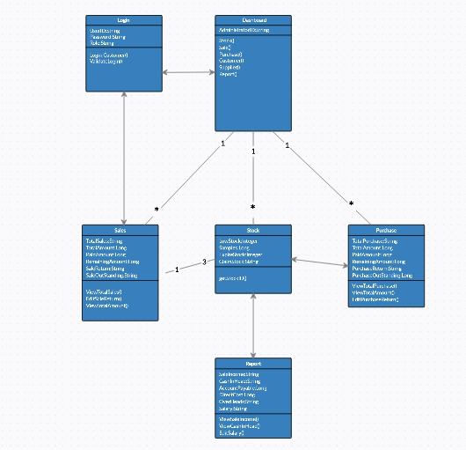**Class Diagram**:

Figure (1)

Admin

### 

**Use Case Diagram**

Figure (2)

Teacher

Admin

### **ER-Diagram:**

**User**

**Admin**

**Customerr**

Is A

N

**Warehouse**

**Supplier**

**Report**

N

**Purchase**

**Sale**

**HAS**

**Stock**

N N

### 

Figure (3)

**State Chart Diagram:**

Log In

Authentication

Read & Write Tagged Items

Manage Accounts & Transactions

Manage Sale & Purchase

Log Out

Manage Supplier

Manage Customer

Manage User

Figure (4)

### **Activity Diagram:**

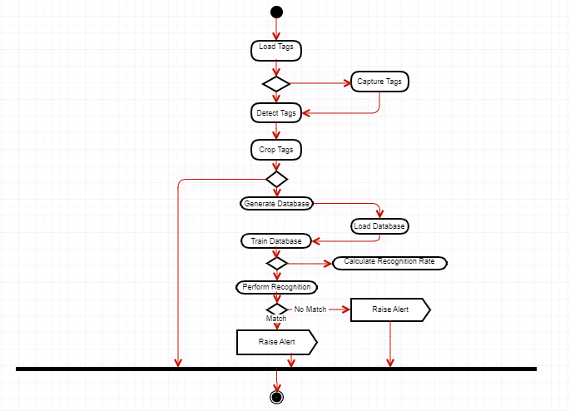

Figure (5)

## 

## **Database Design:**

Important Tables used to store Data are following:

* Stock
* Sale
* Purchase
* Customer
* Supplier
* Transactions

**Stock Table:** Table that will store information of the Stock.

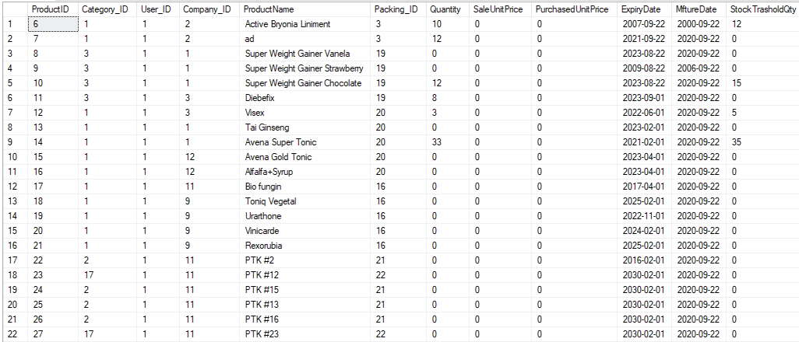

Figure (6)

**Sale Table:** Table in which information is stored regarding Sale.

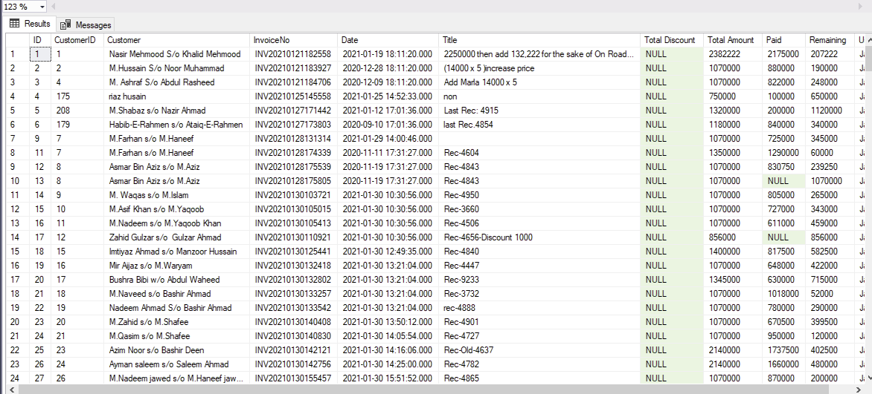

Figure (7)

**Purchase Table:** Table in which information is stored regarding Purchase.

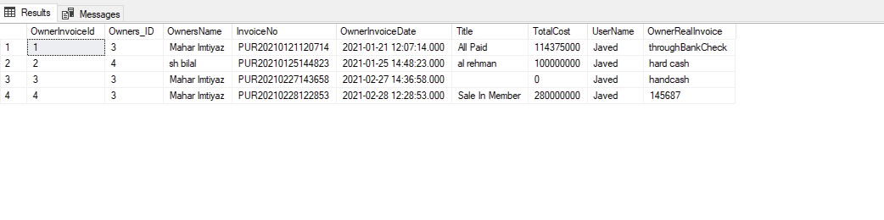

Figure (8)

**Customer Table:** Table in which information is stored regarding Customer.

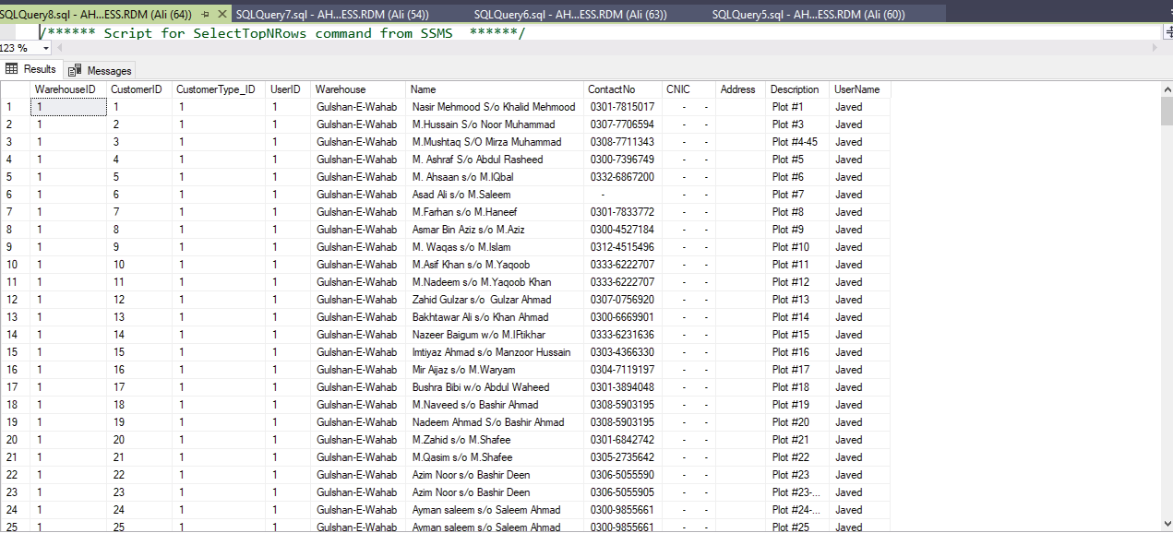

Figure (9)

**Supplier Table:** Table in which information is stored regarding Supplier.

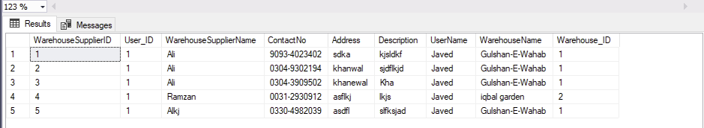

Figure (10)

**Transactions Table:** Table in which information is stored regarding Transactions.

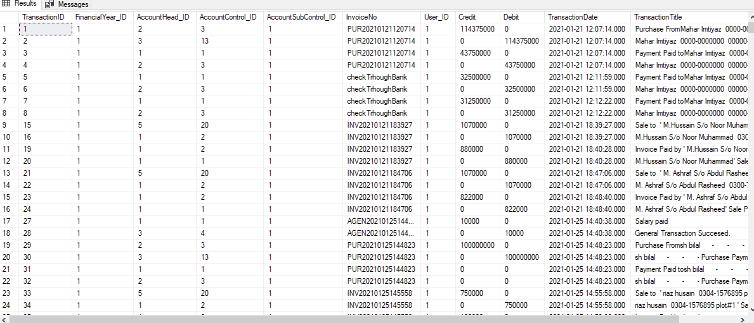

Figure (11)

# 

# Chapter 4

# Result and Analysis

## **Implementation:**

This chapter will focus on the implementation of the RFID system and how it has been developed iteratively. Implementation is the important stage of project when the theoretical design is tuned into practical system. Also, a detailed description of the functionalities implemented with stages of how the prototype has evolved to completion will be discussed.

The first step in implementing the system is to create a database for Warehouse. In actual implementation this step must be a part of the fetching process where we collect the necessary information of the stock. The recognition of RFID Tags are challenging in our Project. The Tag is our essential center of in our project and playing a critical part..

RFID tracking System will implement stock details, sale details, purchase details, customer details, supplier details, and a report detail and separate login details. It will used to entered tag wise information. This application elaborate all RFID tracking system generate weekly, consolidate report provide to the warehouse owners. Mostly this application will calculate month wise report. To select starting date to end date generate reports at the time of activities.

The tools, techniques and technologies that we used to implement this project are:

* C#
* SQL Server Express Edition 2017
* Java
* Android Studio

**Here I’m going to show you some important code.**

Connection With Database:

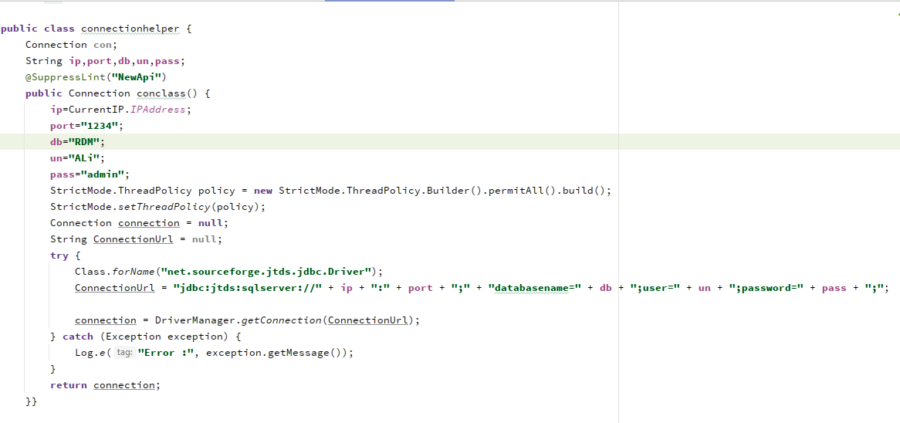

Figure (12)

Front End Code:

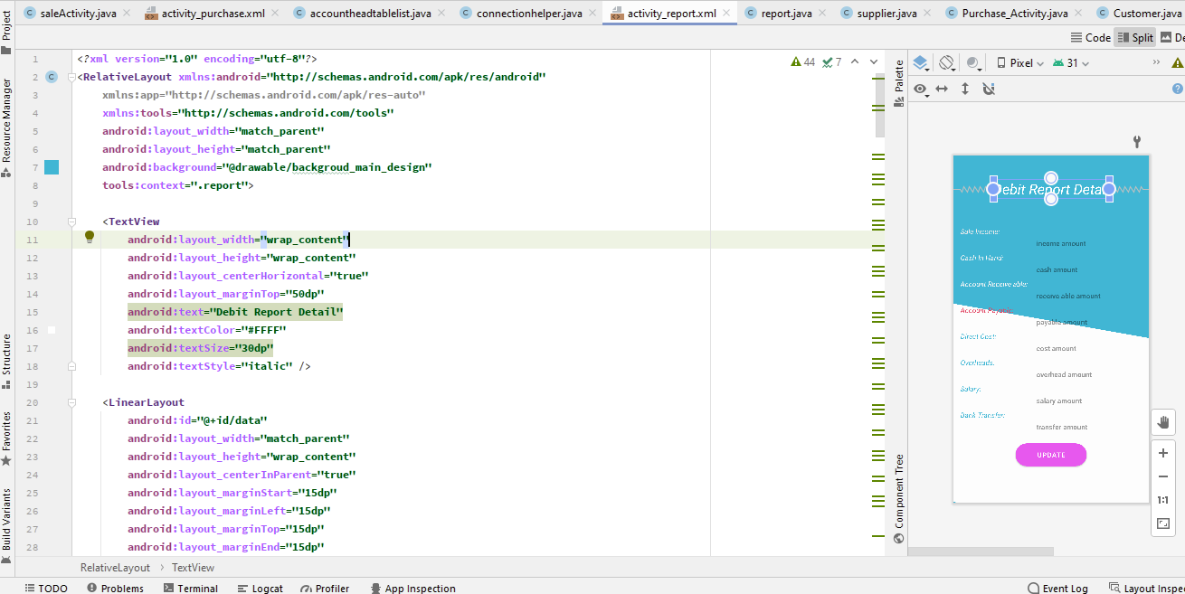

Figure (13)

Fetching Data from Database:

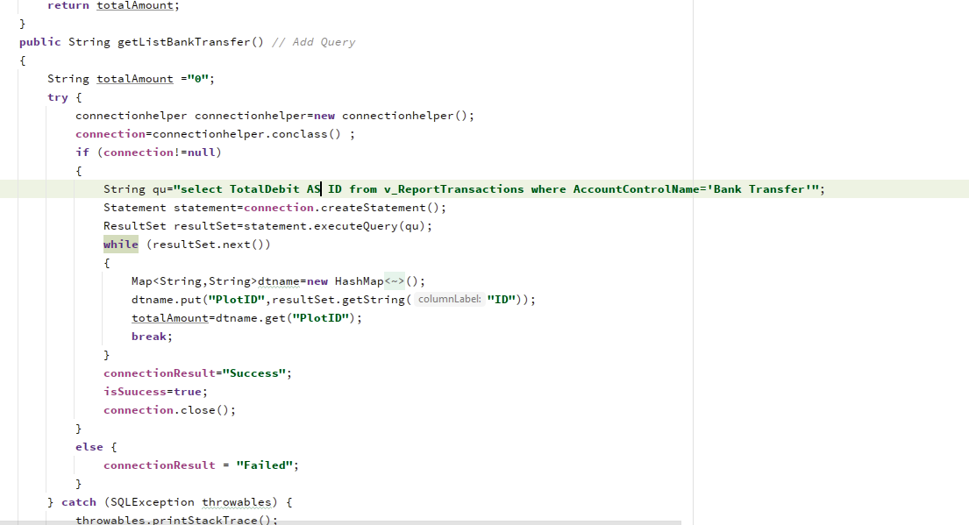

Figure (14)

Setting Up Data In Defined Text Views:

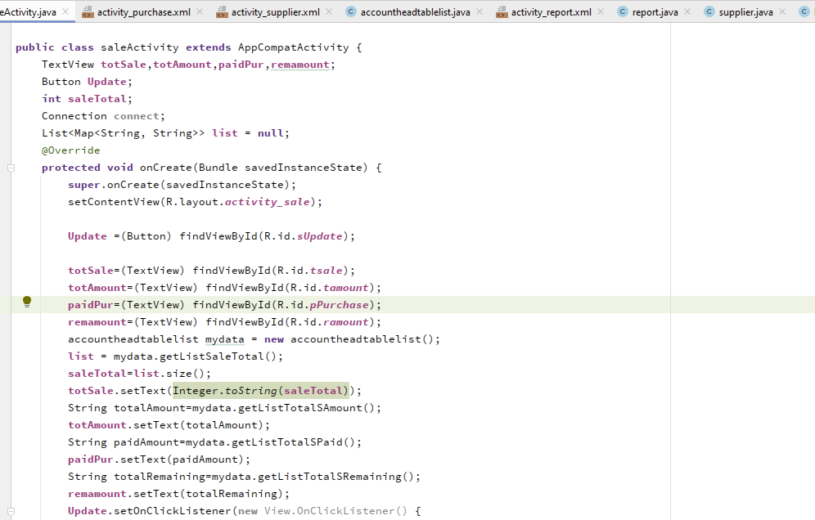

Figure (15)

## **User Interface:**

The Graphical user interface has been designed to allow the user to interact with the system. This has been implemented using C#, Bunifu , Java &.XML.

Most of the desktop page have filtering functions that are actually executed from C# file where query is used to filter the required data from the database. In this project, all the created C# files are stored. The followings are the corresponding C# file working behind the service provided by the desktop page.

**Data Forms:**

* Sale Form addsales
* Purchase Form addpurchase
* Transaction Form addtansaction

### **Login View Of Desktop Application:**

Figure (16)

There are two types of users can login through this page:

1. Admin
2. User (that will be a working employee in the warehouse)

When you login as an admin, the **admin** dashboard will be opened after checking credentials that admin will provide.

### **Dashboard Of Desktop Application:**

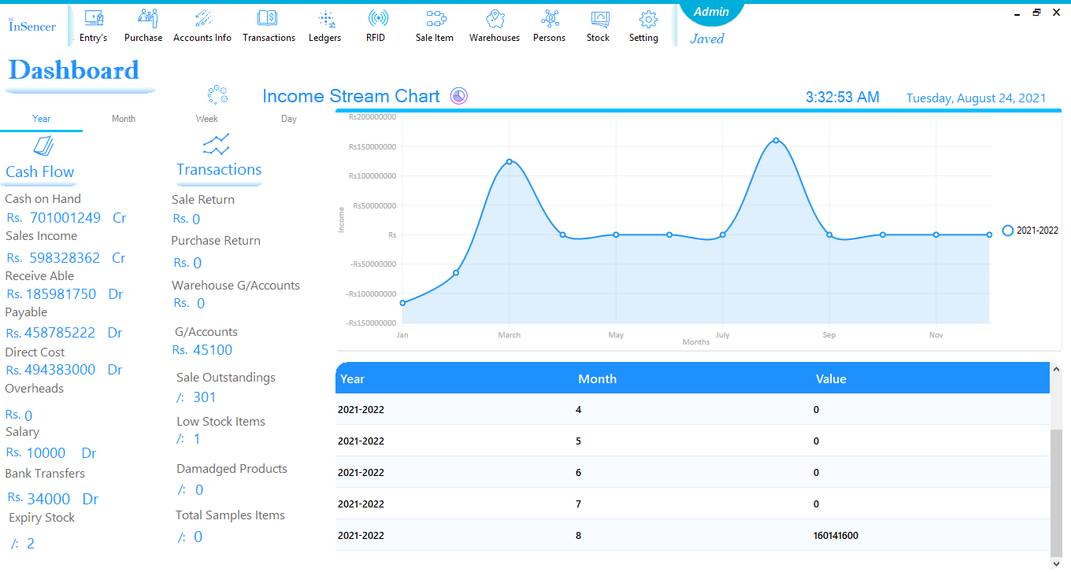

Figure (17)

### **Menu Bar Of Desktop Application:**

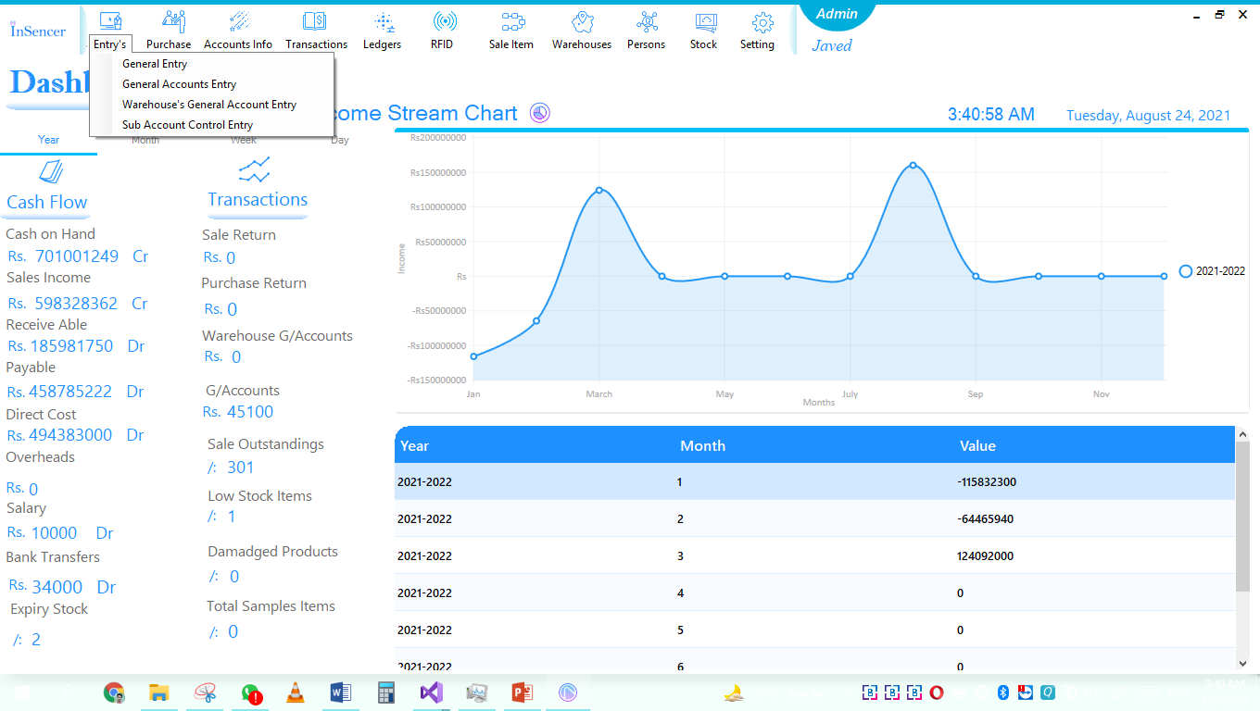

Figure (18)

**Trial Balance Of Desktop Application:**

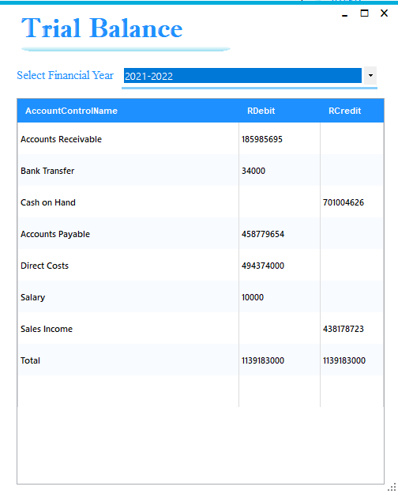

Figure (19)

**Income Statement Of Desktop Application:**

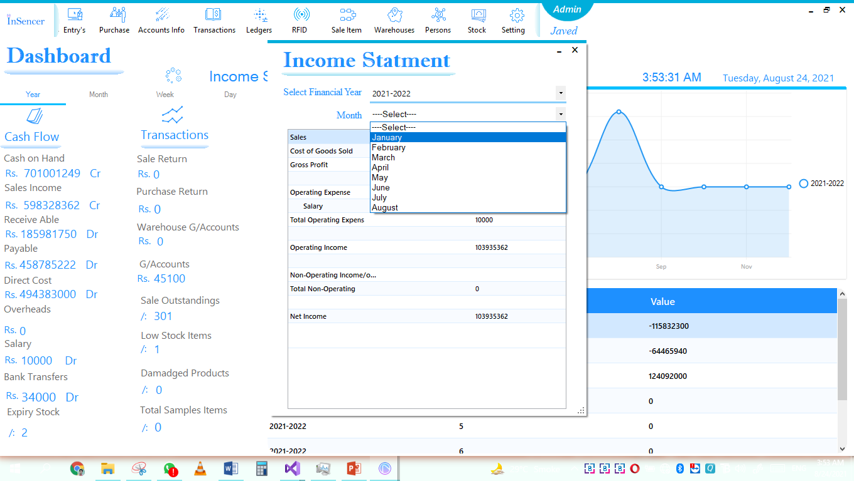

Figure (20)

**Balance Sheet Of Desktop Application:**

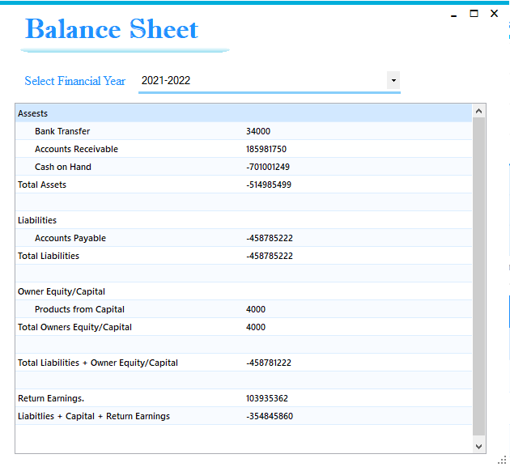

Figure (21)

**Journal Transactions Of Desktop Application:**

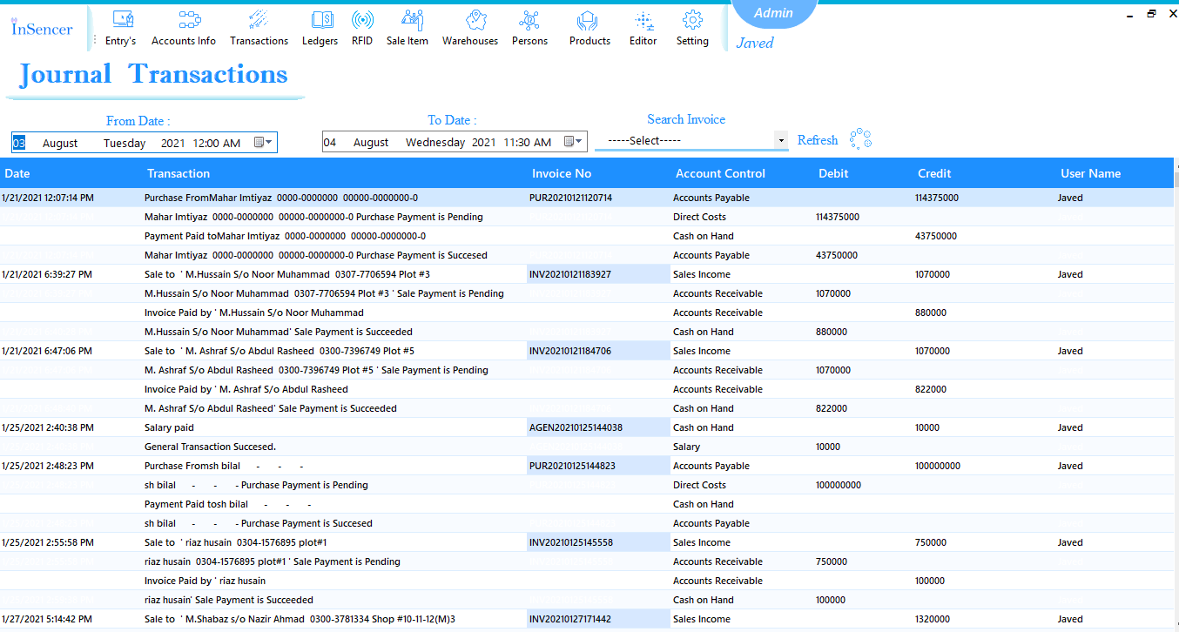

Figure (22)

**General Ledger Of Desktop Application:**

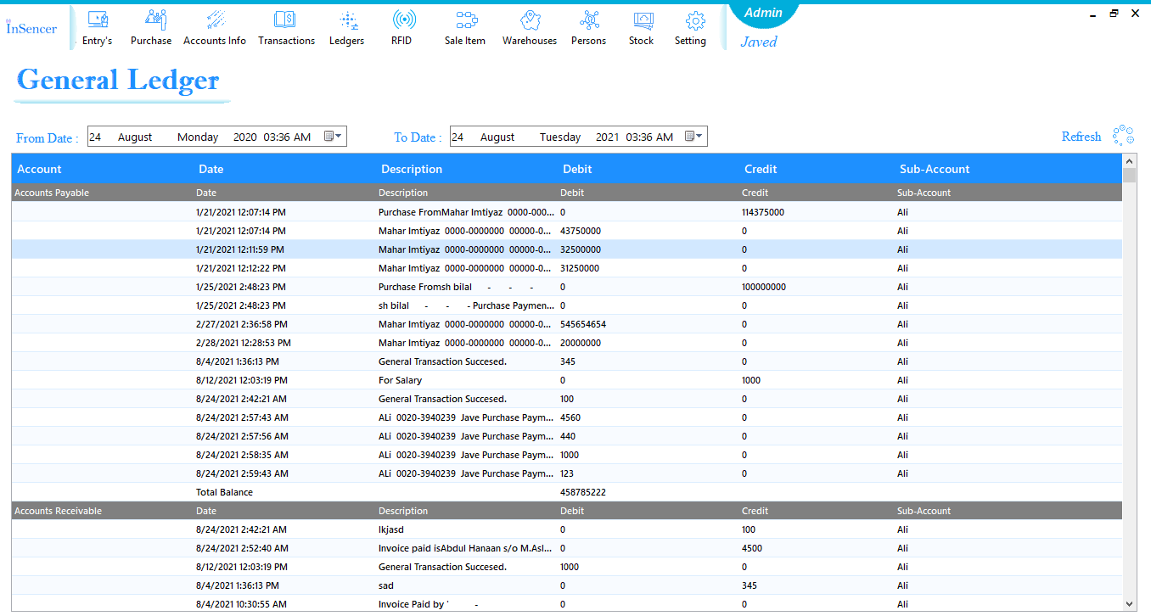

Figure (23)

**Control Account Ledger Of Desktop Application:**

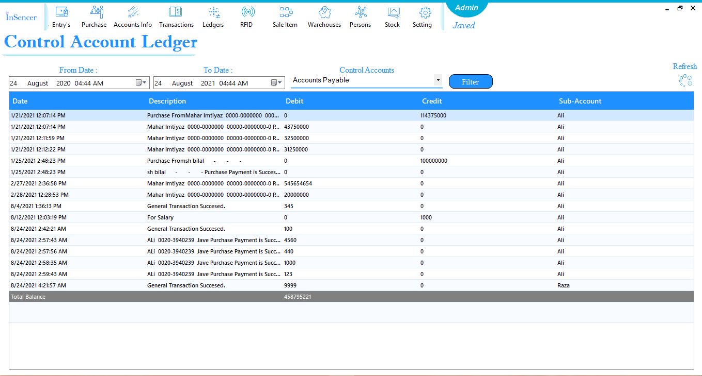

Figure (24)

**Customer’s Ledger of Desktop Application:**

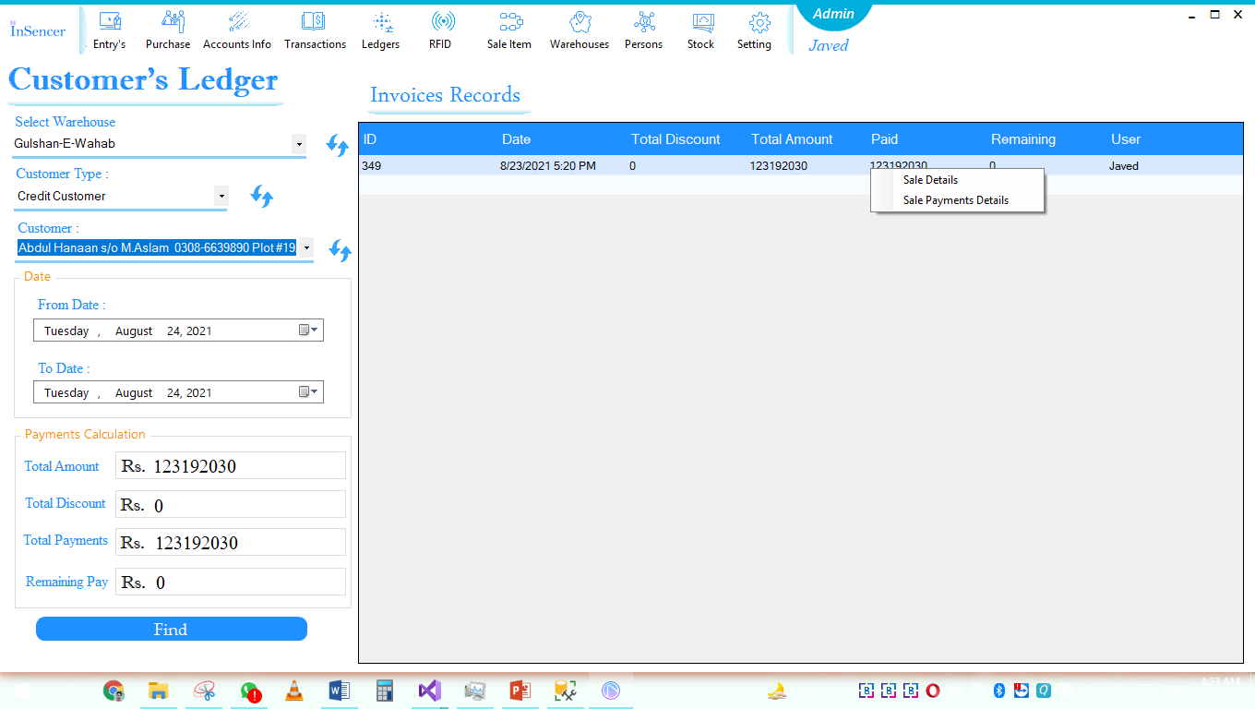

Figure (25)

**Product’s Entry Of Desktop Application:**

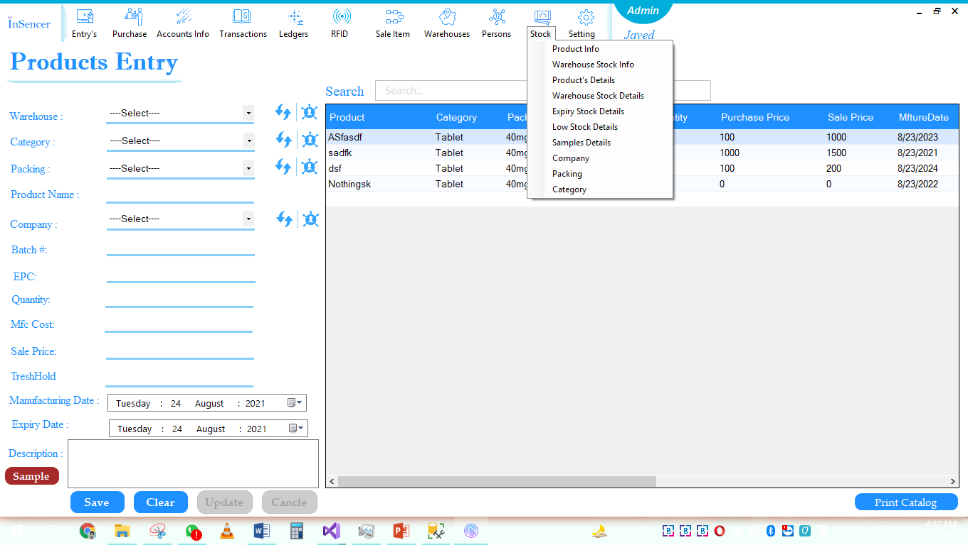

Figure (26)

**Expiry Products of Desktop Application:**

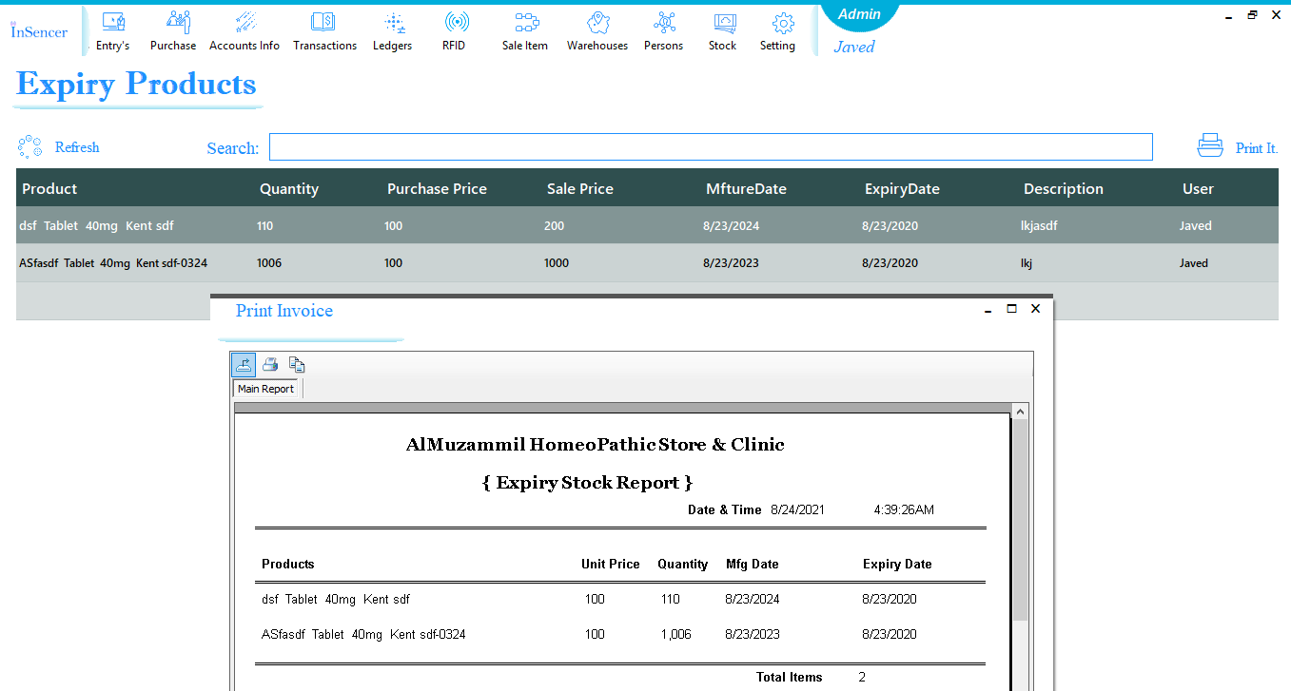

Figure (27)

**Invoice Panel of Desktop Application:**

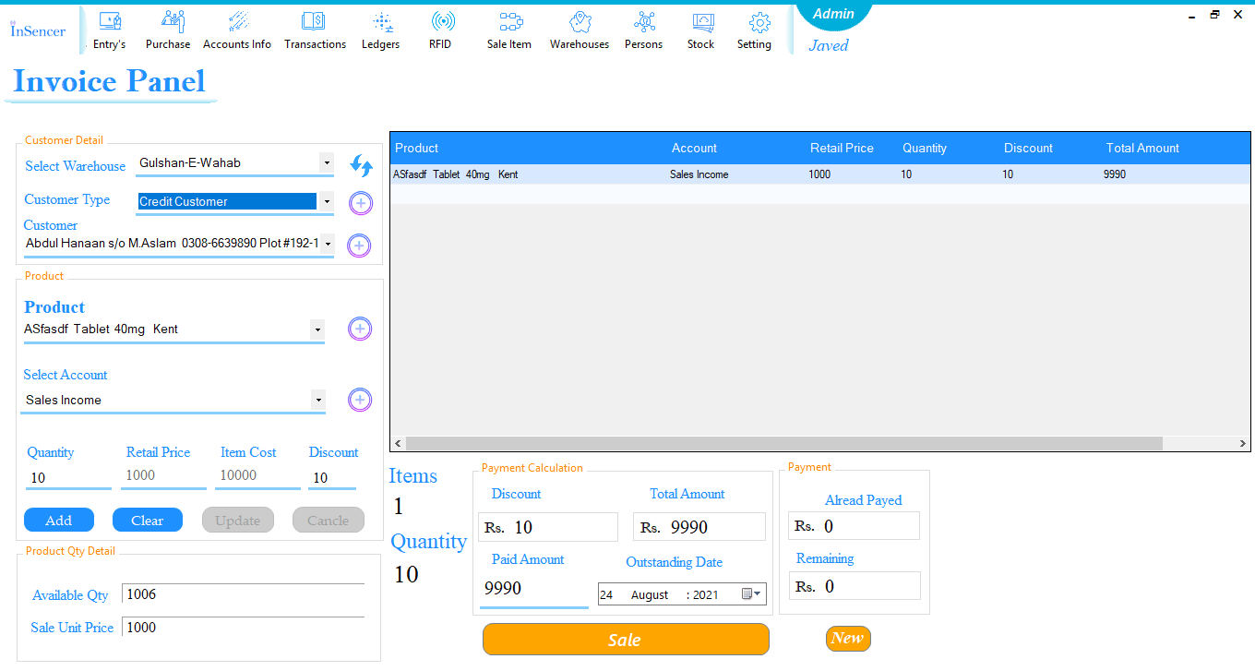

Figure (28)

**Sale Payment of Desktop Application:**

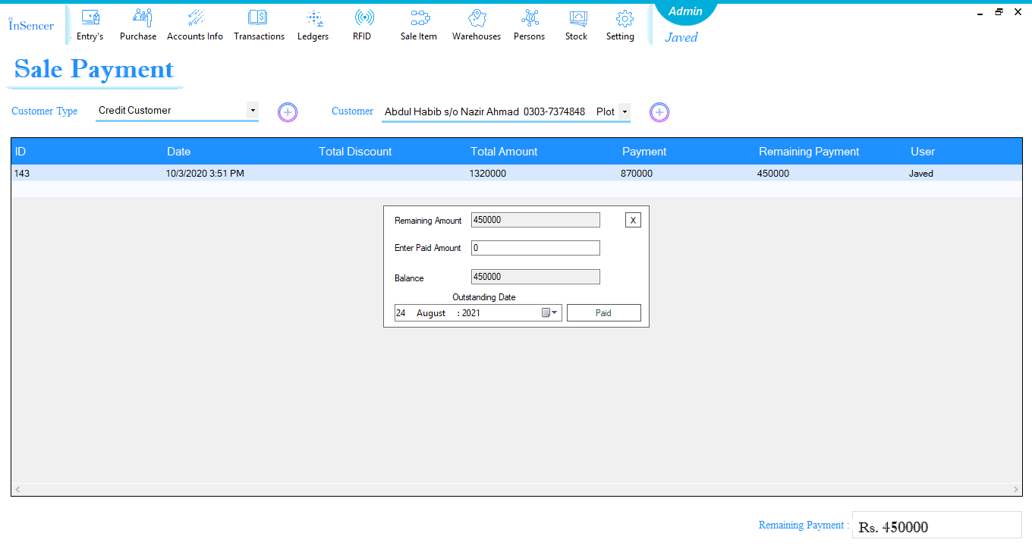

Figure (29)

**General Purchase Payment of Desktop Application:**

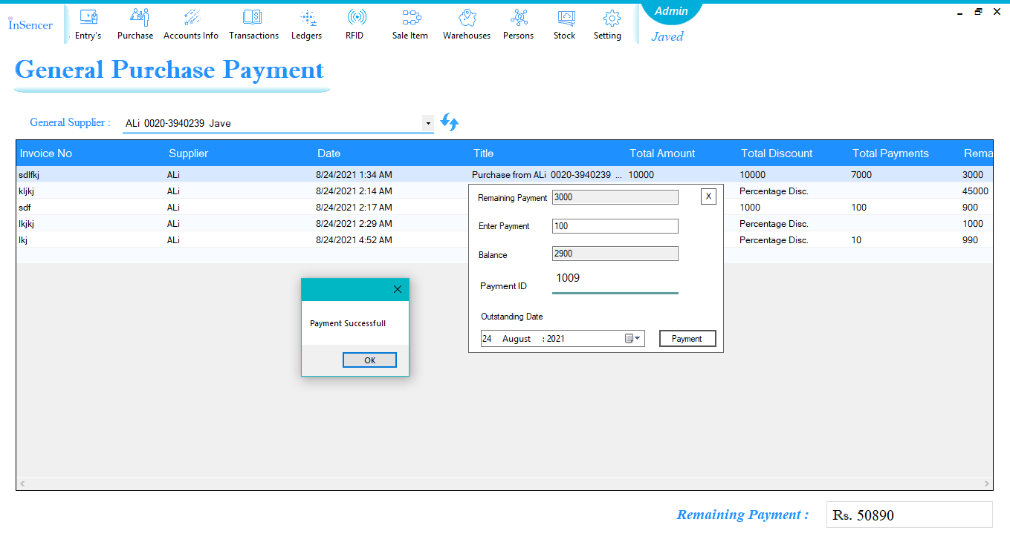

Figure (30)

**Connection and Read EPC:**

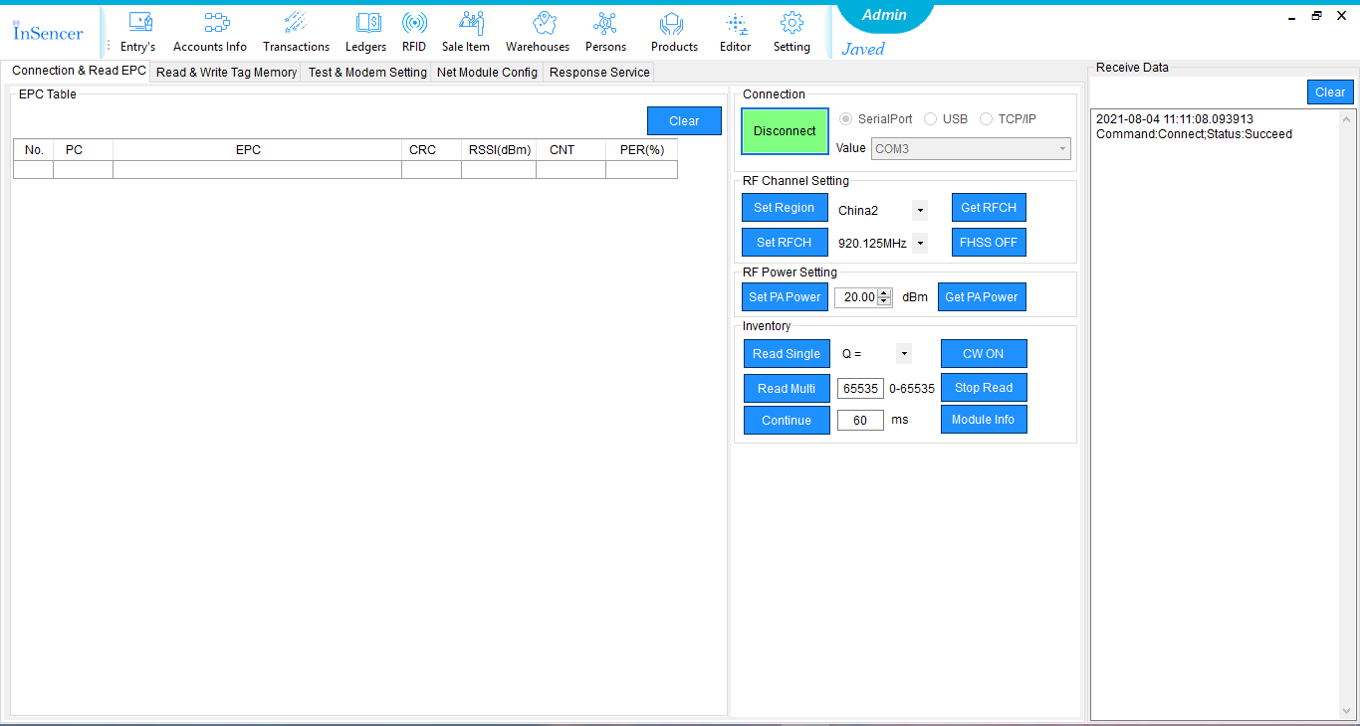

Figure (31)

**Read & Write Tag Memory:**

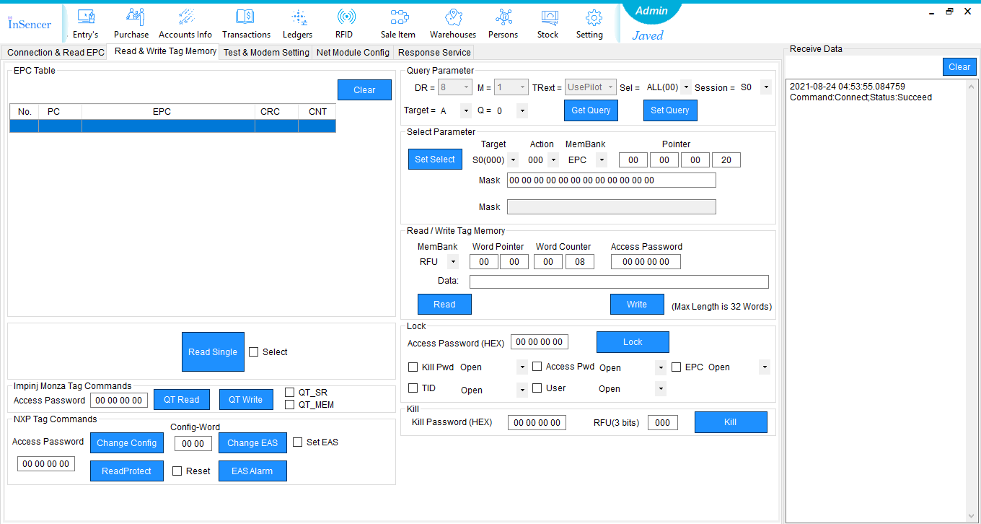

Figure (32)

**Test & Modem Setting:**

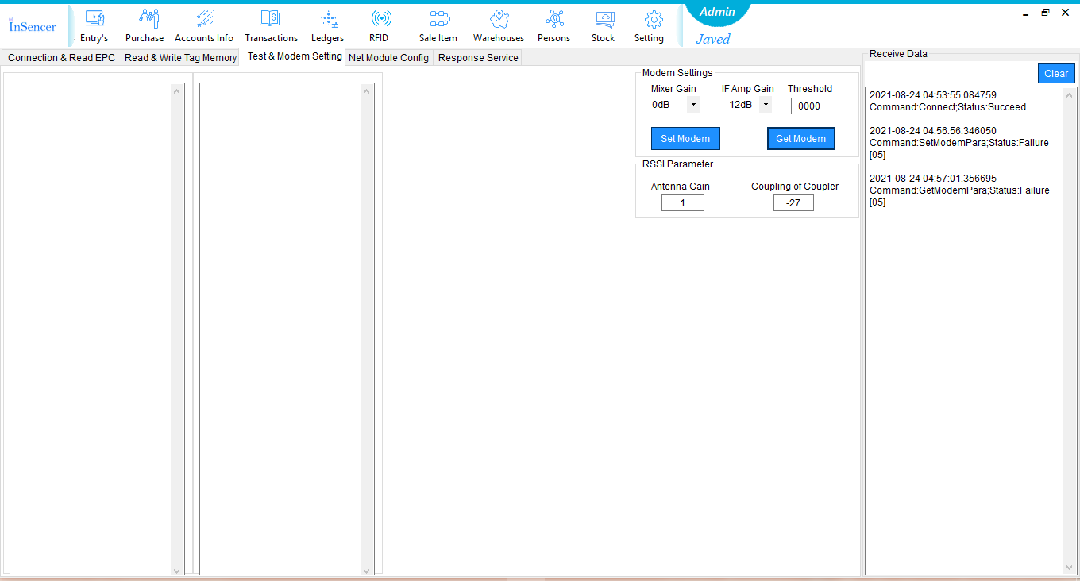

Figure (33)

**.Net Module Config:**

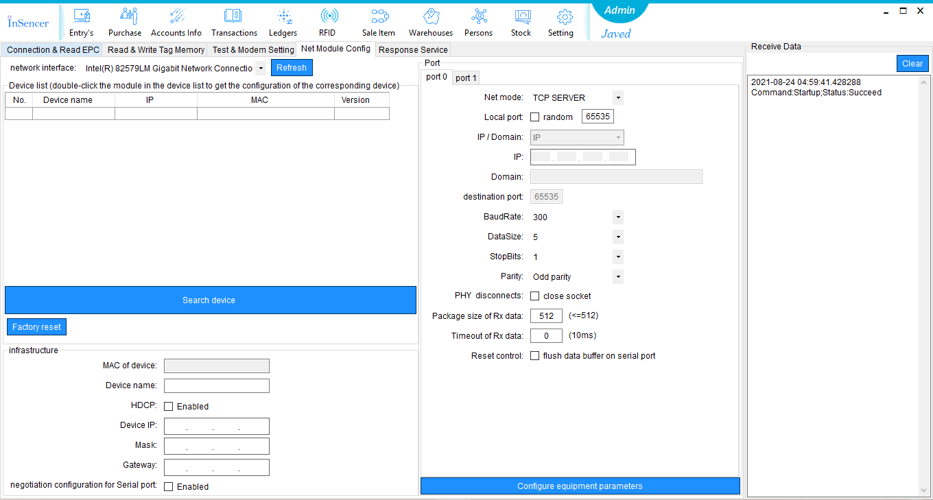

Figure (34)

**Response Service:**

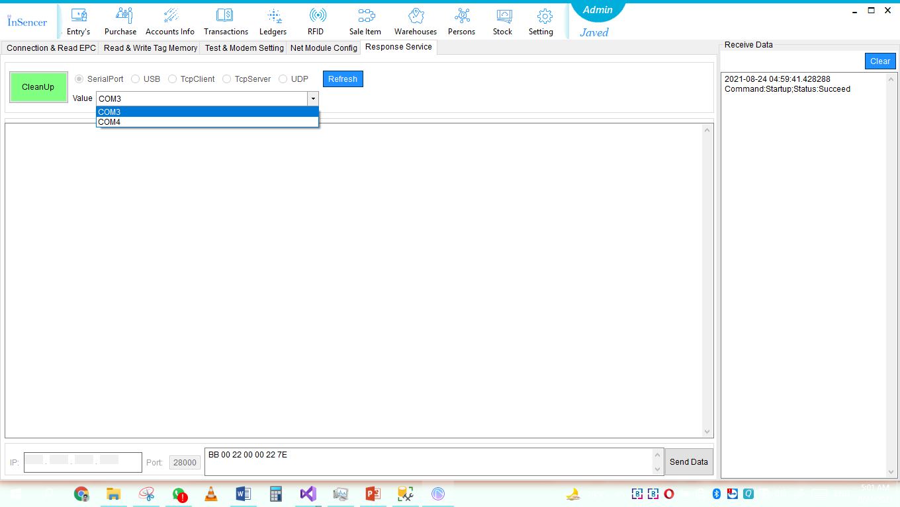

Figure (35)

**Login And Dashboard View in Android Application:**

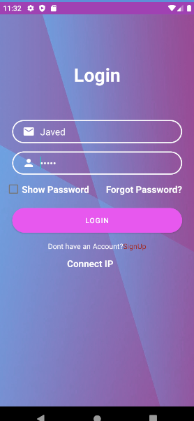

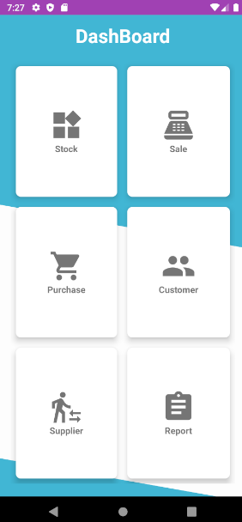

Figure (36)

Figure (37)

**Stock And Sale Detail in Android Application:**

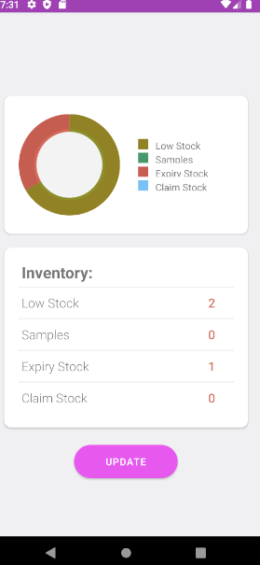

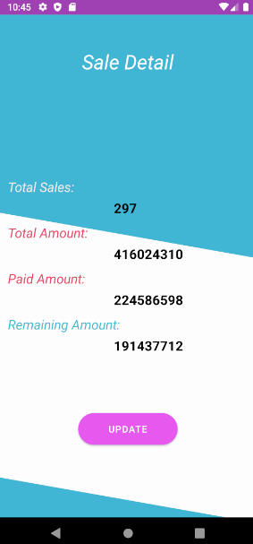

Figure (39)

Figure (38)

**Purchase And Customer Detail in Android Application:**

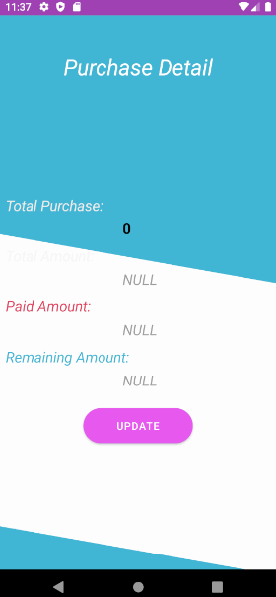

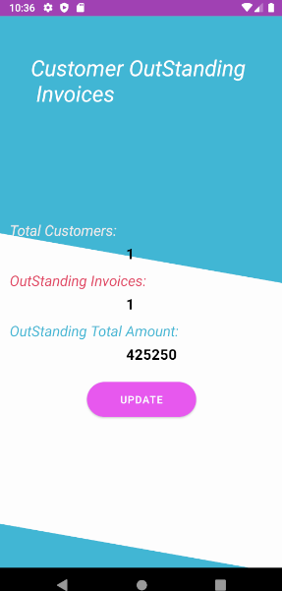

Figure (40)

Figure (41)

**Supplier And Report Detail in Android Application:**

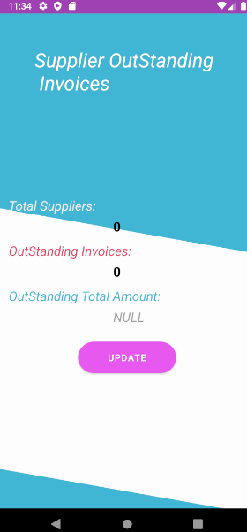

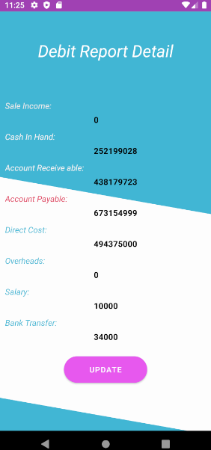

Figure (42)

Figure (43)

# Chapter 5

# CONCLUSION & FUTURE WORK

## **Conclusion:**

In this project we have developed a system in which a company can manage its warehouses. From order picking to delivering all the accounting part is being perform by our system. Managers will manage to check the report of warehouses on their mobile phone. It is easier to manage their warehouse’s accounts, Transactions, and Items. This system will not only make easiness but also prevent company from any major loss like accidental redundancy and wrong Transactions. This system helps to check what is coming in this company from where and why.

In this project we have successfully developed a desktop application that can control A to Z transactions through double entry accounting technique. Not only has this but also showed the progress of the company on their dashboard. Nearly every aspect of sale and purchase can be done by this software. RFID tracking system is built in this desktop application which can read tags and write tags. Then this software can show the stock from every side. Like how much is expired, how many are on their low stock quantity, how much do company has claim, samples, what are the types of companies their products have. Daily, weekly, Monthly, and yearly transactions are shown on the dashboard. We have also developed a mobile application in which manager can check their company’s progress, their inventory reports at one click. Sale Income, Sale Return, Purchase Cost, Purchase return, Total Sales, Receivable, and Payable can be check at one click.

## **Future Work**

Our project is doing Sales, Purchases, Accounting Management, and Inventory Tracking and also show these points on mobile phone. But in some sort of limited features. Like managers can only check from our desktop application any type information like how much sales are done from specific time of period. What transactions are done within a time difference Inventory report can be check how much expired and low stock are. But what are can only be done on desktop application not on mobile application.

* Put an activity in mobile application in which we can check what are the items are expired.
* Put an activity in mobile application in which transactions with time difference can be check.
* Search bar activity in mobile application for searching required inventory and other truncations.
* Warehouses General Supplier’s sales and purchases.
* Auto sale while reading Tags on the counter.
* Auto purchase while reading Tags on the counter.

# 

# Chapter 6

# References

## **References**

* <https://securityintelligence.com/articles/data-breach-protection-physical-security/>
* <https://www.enisa.europa.eu/publications/physical-manipulation-damage-theft-loss/at_download/fullReport>
* <https://www.zoho.com/inventory/guides/common-problems-in-warehouse-management-and-their-solutions.html>
* <https://www.maxxamv.com/product-tag/rfid-warehouse-solution-in-pakistan/>
* <https://rfid.pk/rfid-industrial-applications/warehouse>
* <https://theloadstar.com/more-slash-and-grab-cargo-theft-from-trucks-and-inside-jobs-are-on-the-up/>
* <https://www.satoeurope.com/insight/why-using-rfid-based-solutions-is-now-essential-in-apparel-retail/43>